Contraints: 0

Consulta sem PK

* Connect system/fatec
* Documentar no relatório as constraints da tabela oe.product_descriptions;
* Alter table oe.product_descriptions drop primary key;
* Drop index oe.prd_desc_pk;
* Select *   
  from oe.product_descriptions  
  where product_id = 3060 and language_id =‘US’;
* Anotar o tempo de execução da consulta;

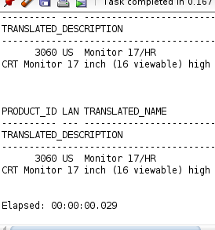

Consulta com PK

* Alter table oe.product_descriptions add primary key (product_id, language_id );
* Select *   
  from oe.product_descriptions  
  where product_id = 3060 and language_id =‘US’;
* Anotar o tempo de execução;
* Observar a diferença de valores

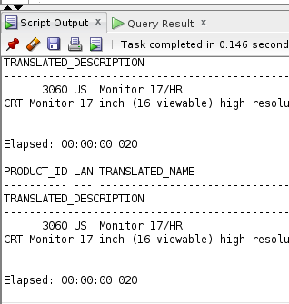

Consulta das vendas sem campo consolidado

* Select cust_id, count(*) from sh.sales group by cust_id;
* Select CUST_ID, sum(AMOUNT_SOLD)  
  from SH.sales   
  WHERE CUST_ID = 116  
  group by CUST_ID;
* Medir o tempo de execução da consulta

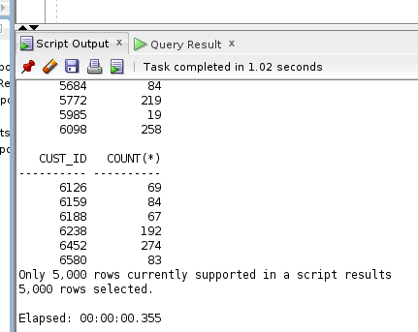

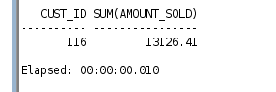

Consulta das vendas com campo consolidado

* Create table sh.sales_summary as Select CUST_ID, sum(AMOUNT_SOLD) AMOUNT_SOLD  
  from SH.sales   
  group by CUST_ID;
* Alter table sh.sales_summary add primary key (CUST_ID);
* Select CUST_ID, AMOUNT_SOLD  
  from SH.sales_summary   
  WHERE CUST_ID = 116;
* Anotar o tempo de execução;
* Observar a diferença de valores

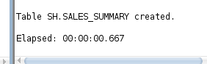

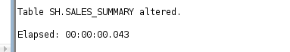

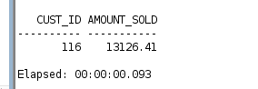

**PARTE 2**

